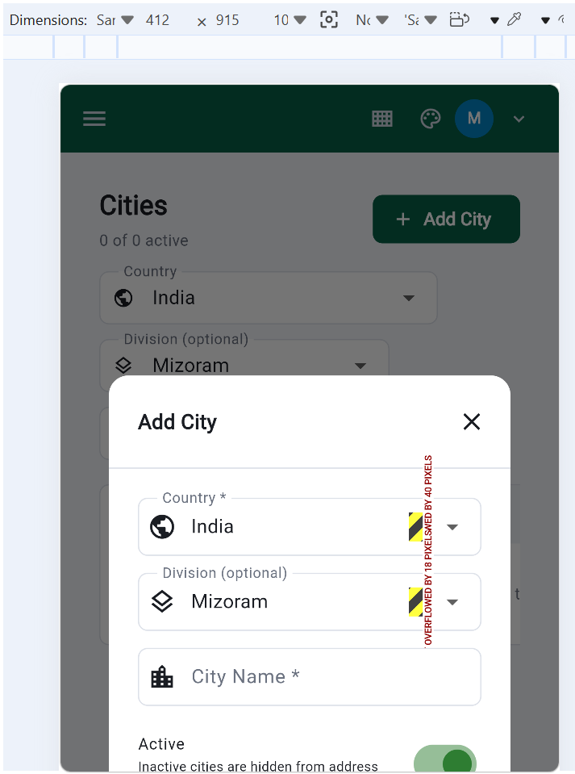

In below image : it is hard to scroll on mobile, Edit and Delete button is not visible
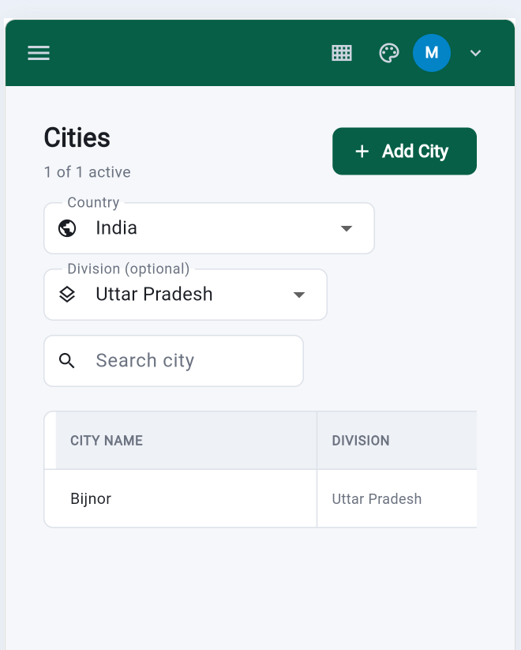

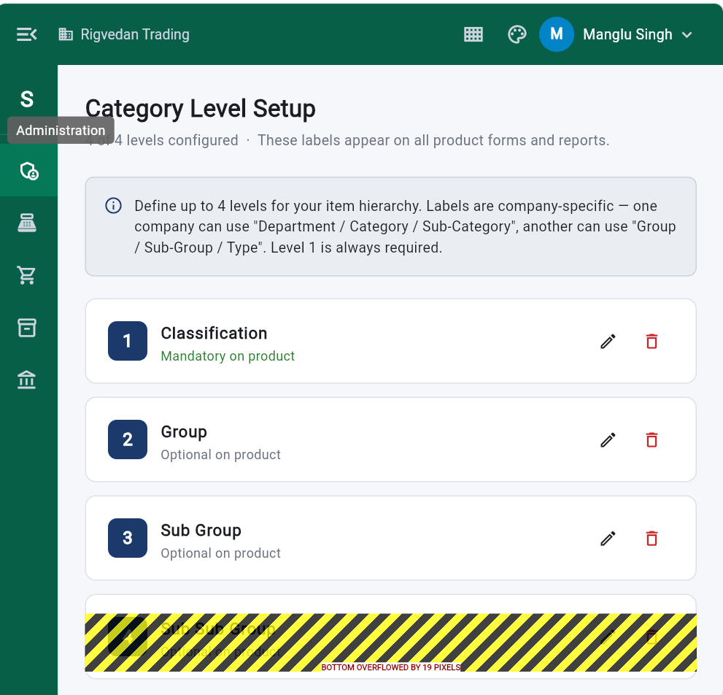

Product List – All Type (Search) is not properly sized.
_error_dumper_web.dart:15 Another exception was thrown: A RenderFlex overflowed by 18 pixels on the right.
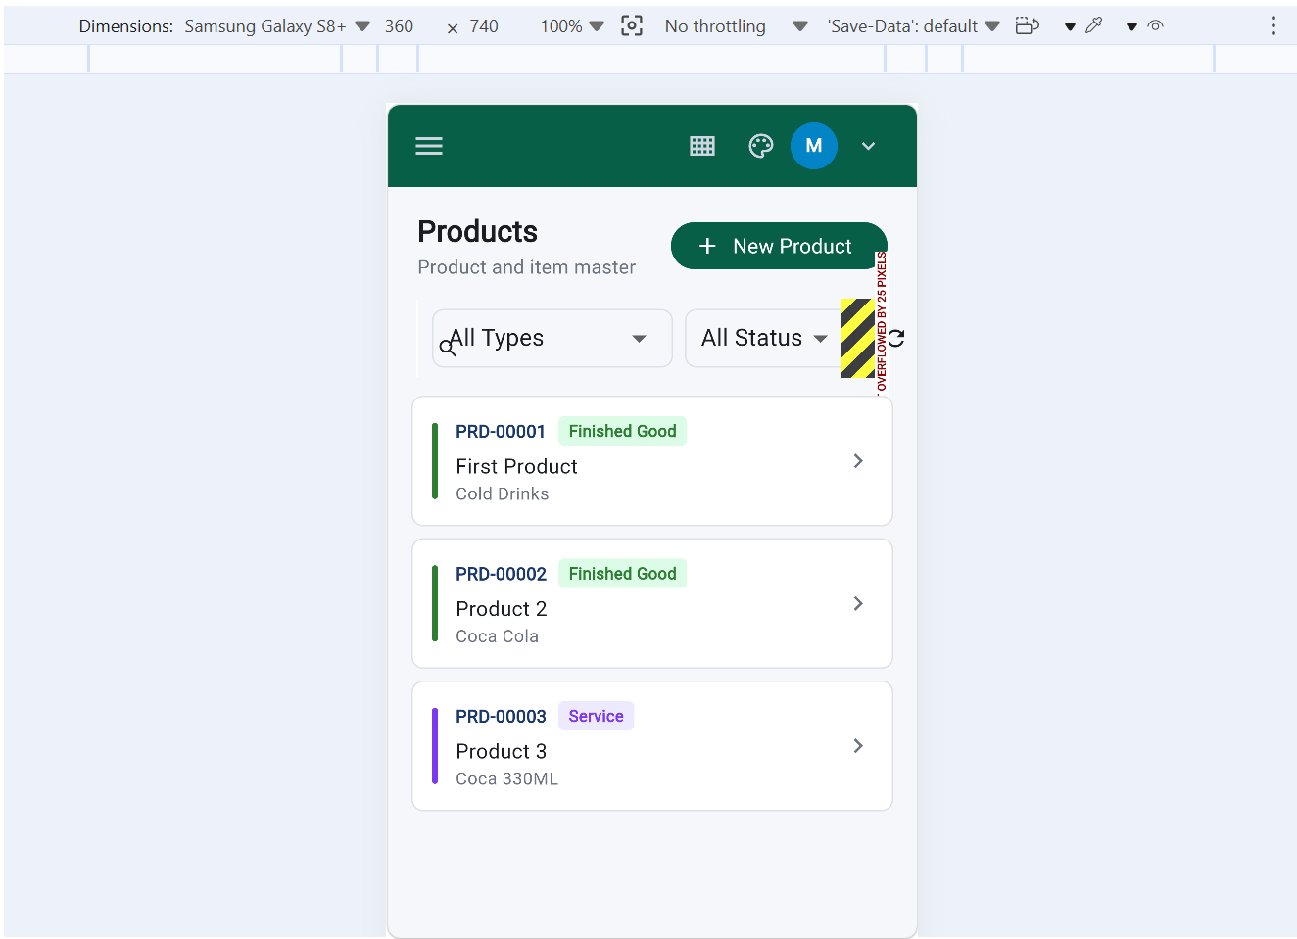

Below is create Product screen
Another exception was thrown: A RenderFlex overflowed by 184 pixels on the right.
dump @ _error_dumper_web.dart:15
_error_dumper_web.dart:15 Another exception was thrown: A RenderFlex overflowed by 3.4 pixels on the right.
dump @ _error_dumper_web.dart:15
dumpErrorToConsole @ assertions.dart:1040
(anonymous) @ operations.dart:118
reportError @ assertions.dart:1193
(anonymous) @ debug_overflow_indicator.dart:259
paintOverflowIndicator @ debug_overflow_indicator.dart:329
(anonymous) @ flex.dart:1449
paint @ flex.dart:1456
(anonymous) @ object.dart:3568
paintChild @ object.dart:265
defaultPaint @ box.dart:3368
paint @ flex.dart:1402
(anonymous) @ object.dart:3568
paintChild @ object.dart:265
paint @ shifted_box.dart:98
(anonymous) @ object.dart:3568
paintChild @ object.dart:265
defaultPaint @ box.dart:3368
paint @ flex.dart:1402
(anonymous) @ object.dart:3568
paintChild @ object.dart:265
paint @ proxy_box.dart:143
(anonymous) @ object.dart:3568
paintChild @ object.dart:265
paint @ proxy_box.dart:143
(anonymous) @ object.dart:3568
_repaintCompositedChild @ object.dart:180
repaintCompositedChild @ object.dart:125
flushPaint @ object.dart:1325
flushPaint @ object.dart:1335
drawFrame @ binding.dart:645
drawFrame @ binding.dart:1573
(anonymous) @ binding.dart:509
(anonymous) @ operations.dart:118
(anonymous) @ binding.dart:1430
handleDrawFrame @ binding.dart:1345
(anonymous) @ binding.dart:1198
(anonymous) @ operations.dart:118
invoke @ platform_dispatcher.dart:1700
invokeOnDrawFrame @ platform_dispatcher.dart:268
(anonymous) @ frame_service.dart:209
(anonymous) @ frame_service.dart:117
runUnary @ zone.dart:962
(anonymous) @ zone.dart:917
_callDartFunctionFast1 @ js_allow_interop_patch.dart:218
(anonymous) @ js_allow_interop_patch.dart:78
_error_dumper_web.dart:15 Another exception was thrown: A RenderFlex overflowed by 16 pixels on the right.
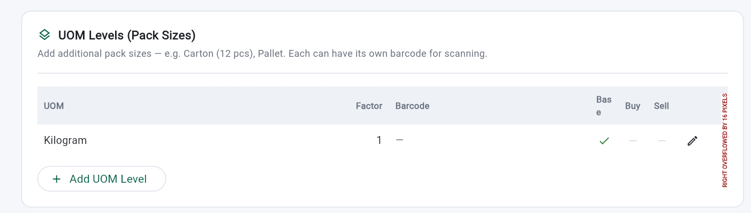
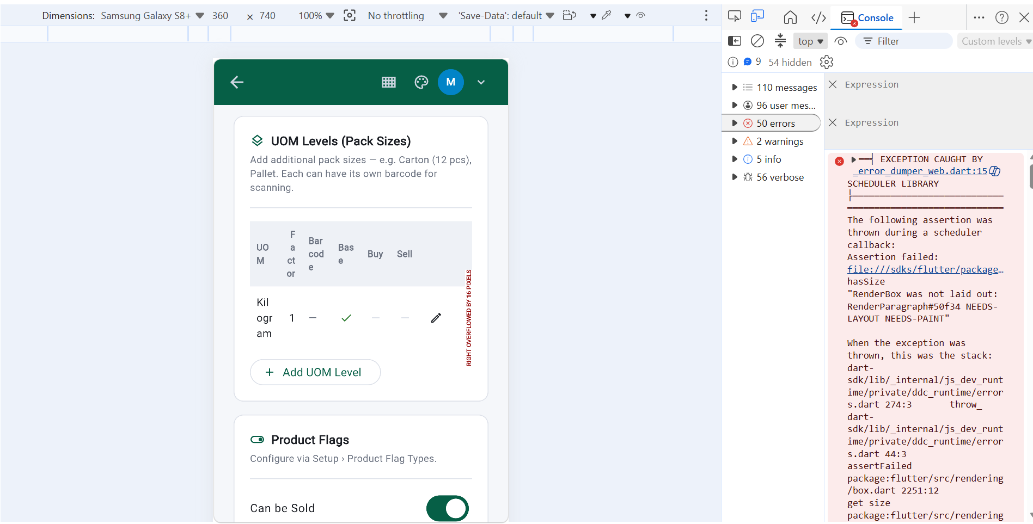

Backdated entry control, save button should be on top also see the resonsiveness

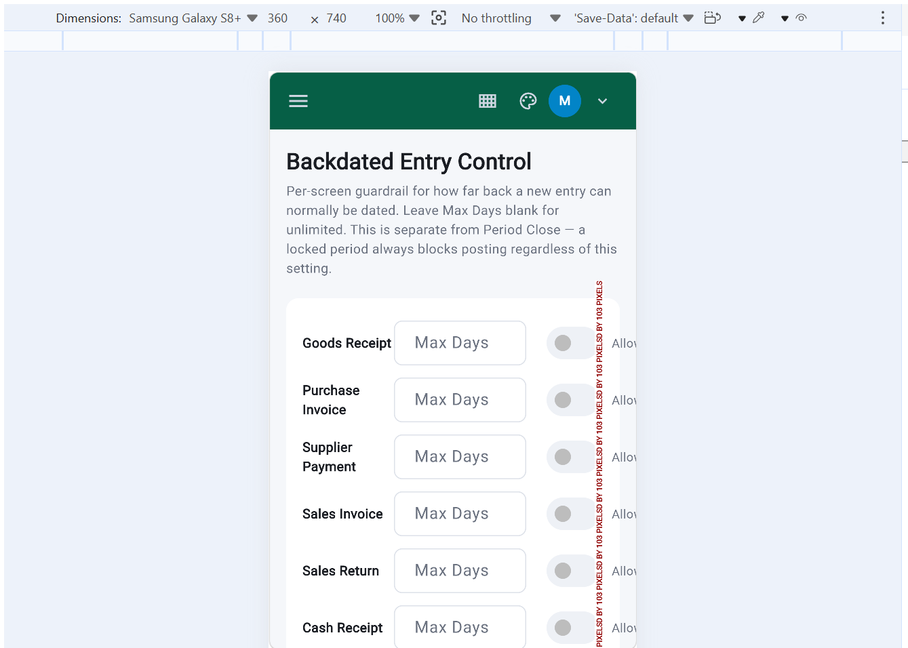

Accountlink setup: user do not know where to click, card is not clickable on mobile
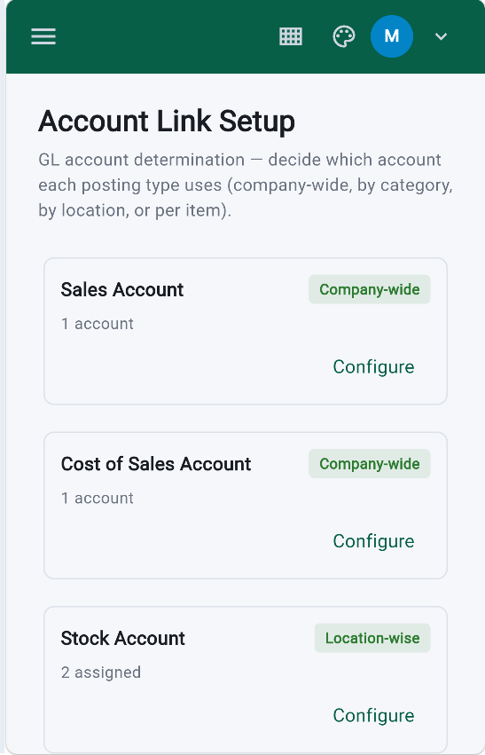

When I click on Configure: two back buton ,looking wieed, should be only one on Navbar only.
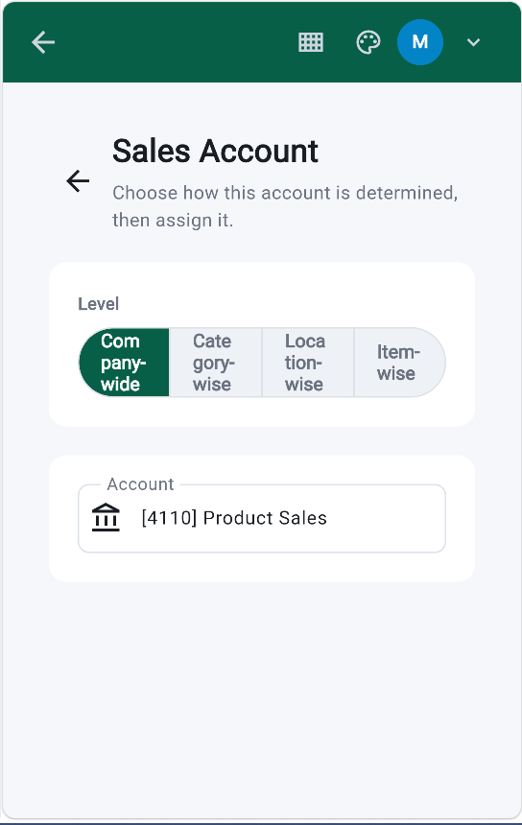
Product category Master
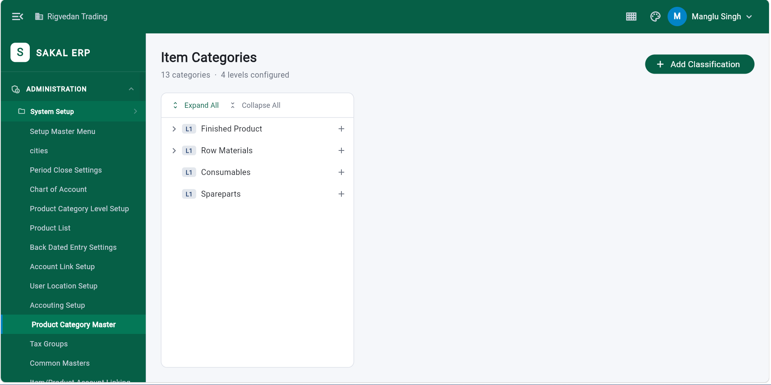

When I click on + , +Add classification should not be visible only save should be visible. User will be confused, where he has to click
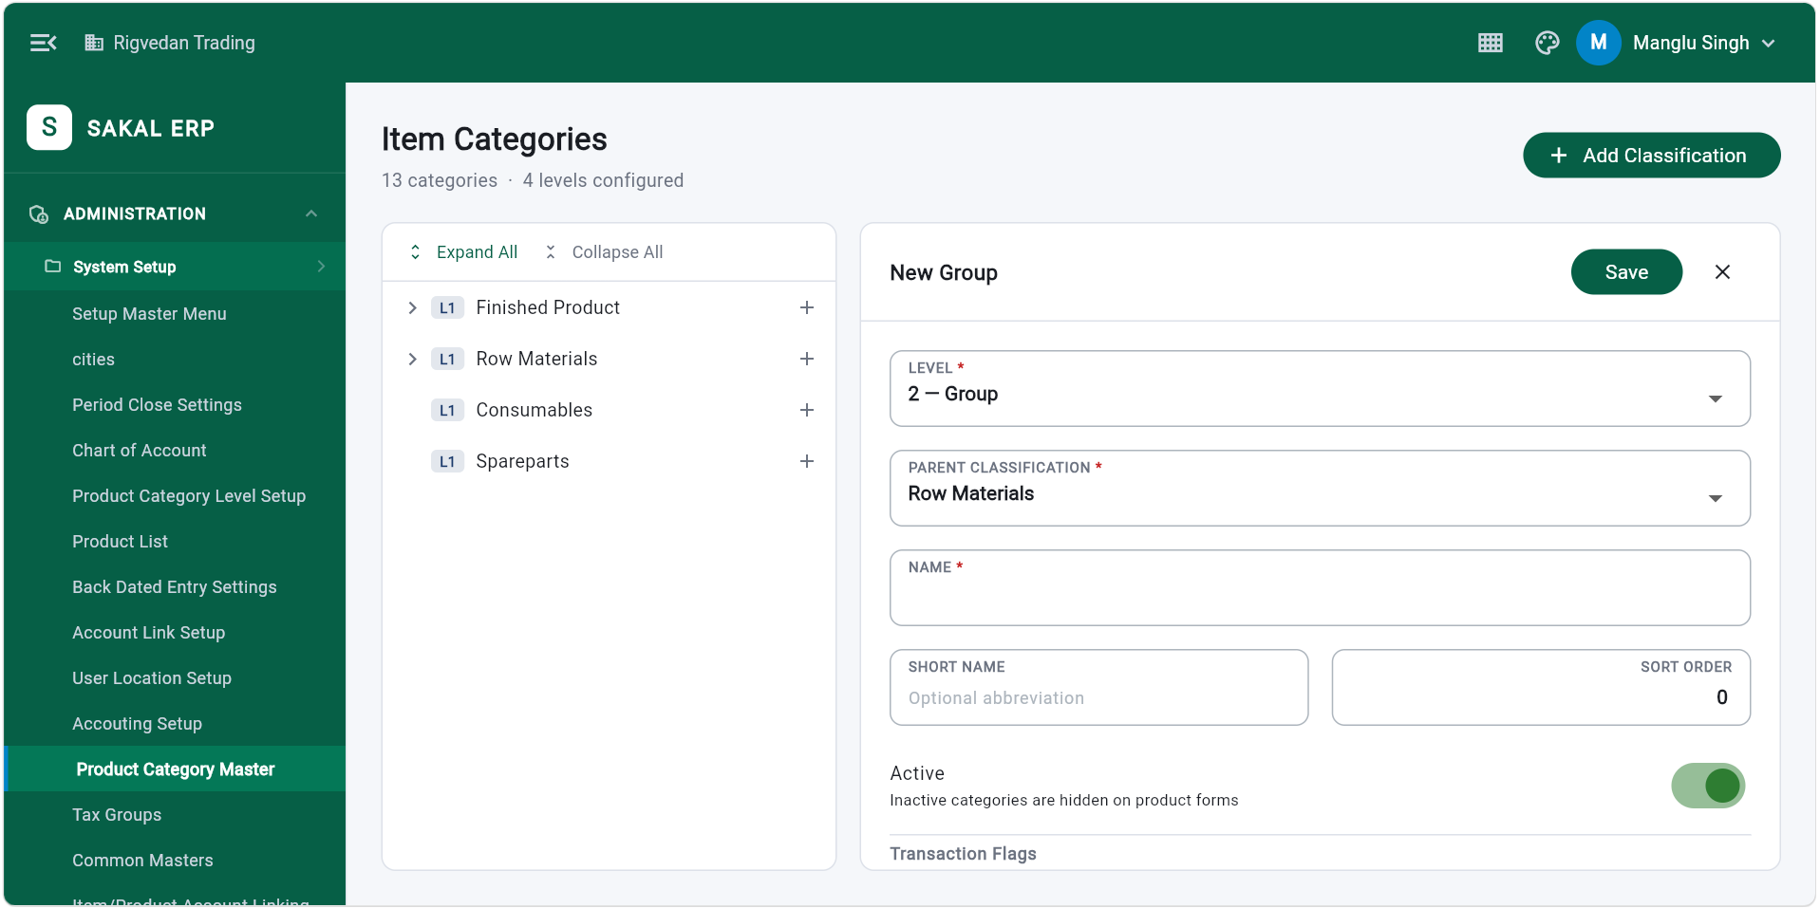

Common Masters
_error_dumper_web.dart:15 Another exception was thrown: Trailing widget consumes the entire tile width (including ListTile.contentPadding).
130
_error_dumper_web.dart:15 Another exception was thrown: ListTile background color or ink splashes may be invisible.
developer_patch.dart:78 dart.developer.log
- Object
_error_dumper_web.dart:15 Another exception was thrown: A RenderFlex overflowed by 43 pixels on the right.
2
_error_dumper_web.dart:15 Another exception was thrown: A RenderFlex overflowed by 43 pixels on the right.
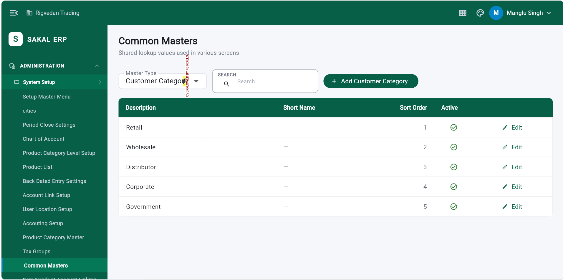

Division : Devision list should be card like on mobile
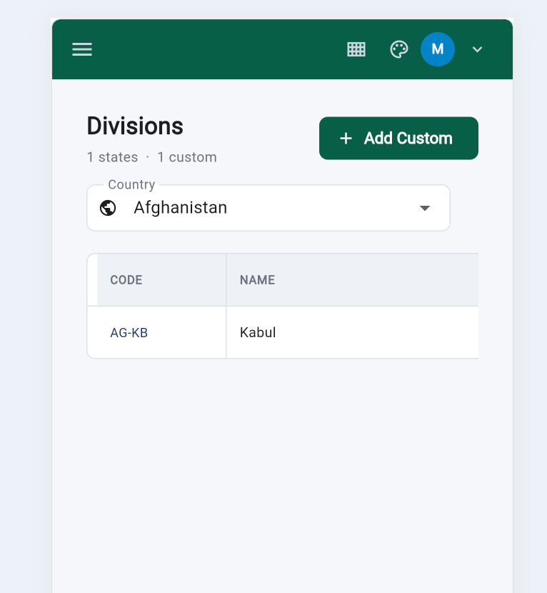

Master Menu should be Sorted Module wise please check best possible sorting option,
it should have a scrollbar also, it is difficult to scroll horizontally,. Pease check mobile view also
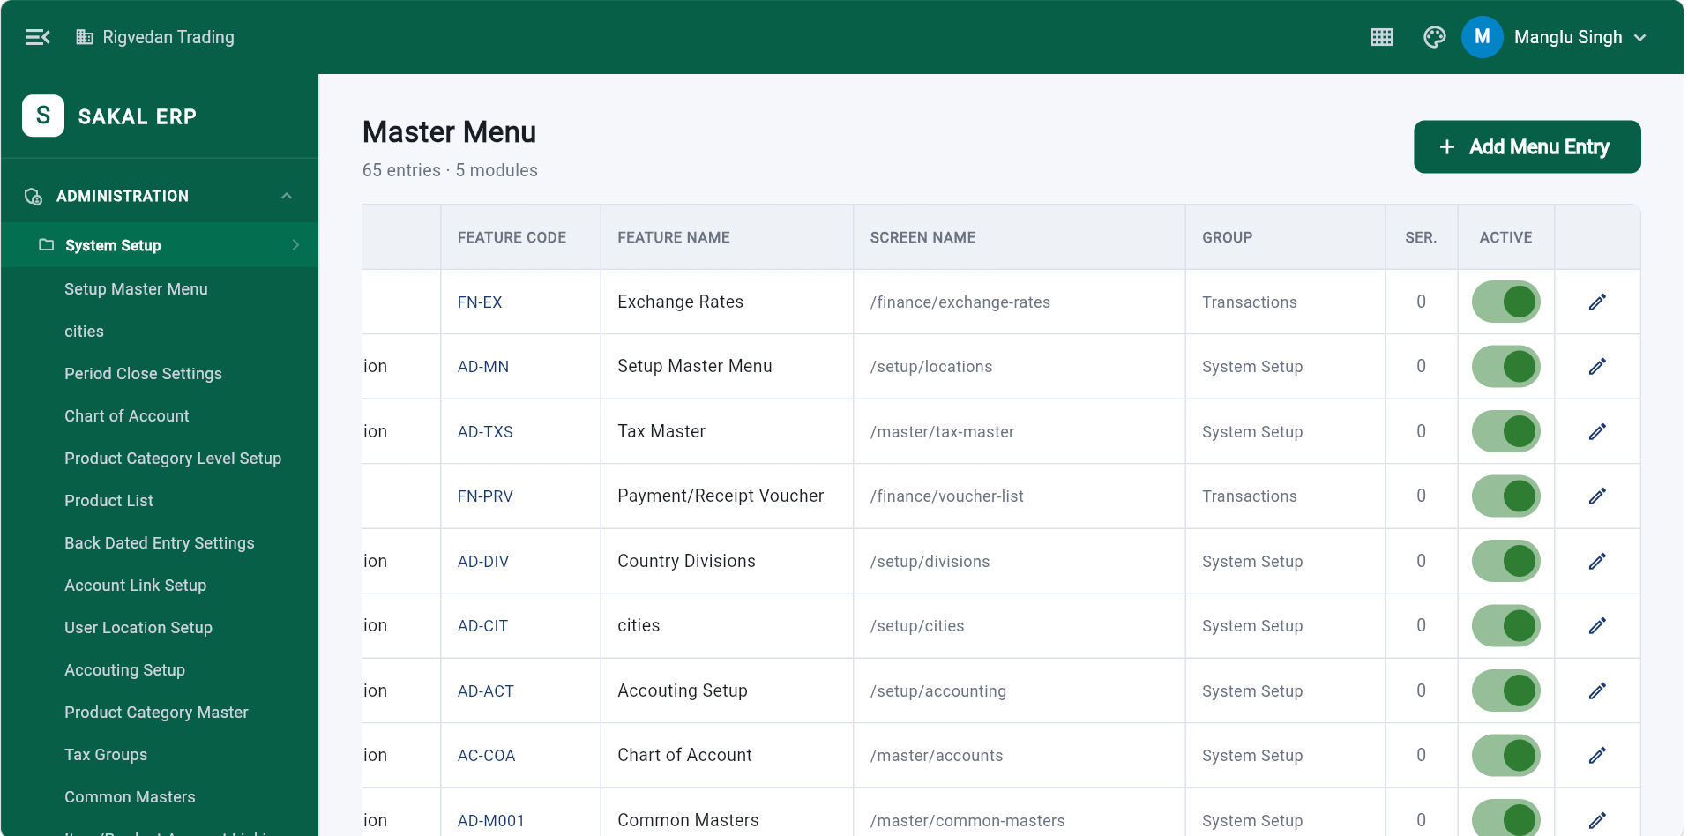

Company Setup (below) Save button should be on top right side (as it is on all screens)
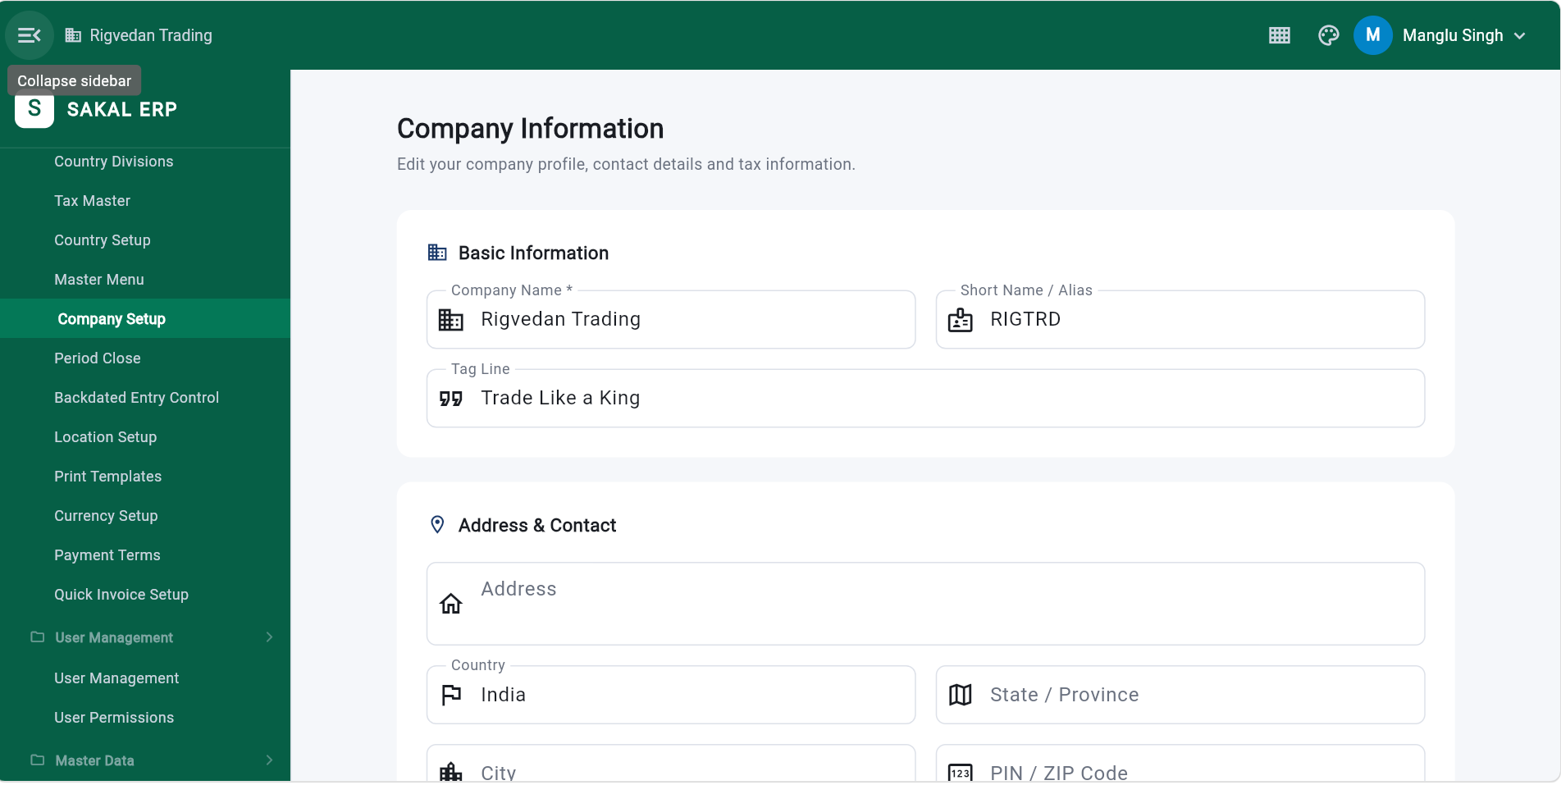

On mobile : please check the view (below image)
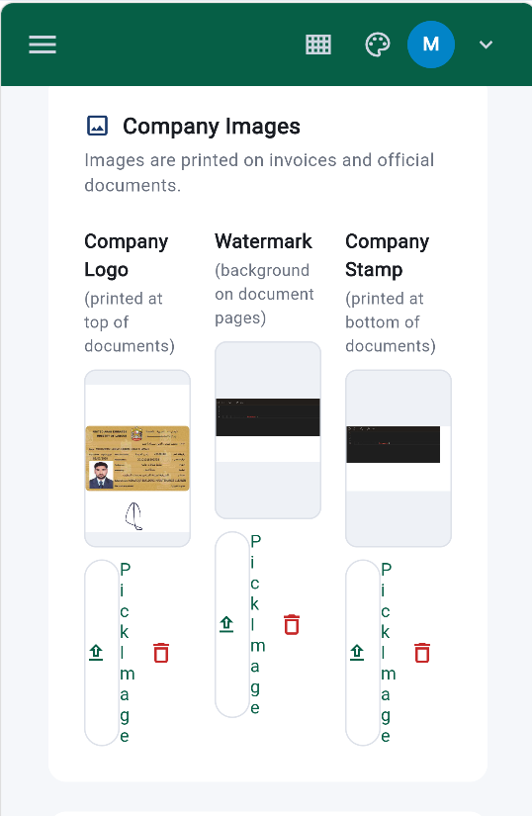
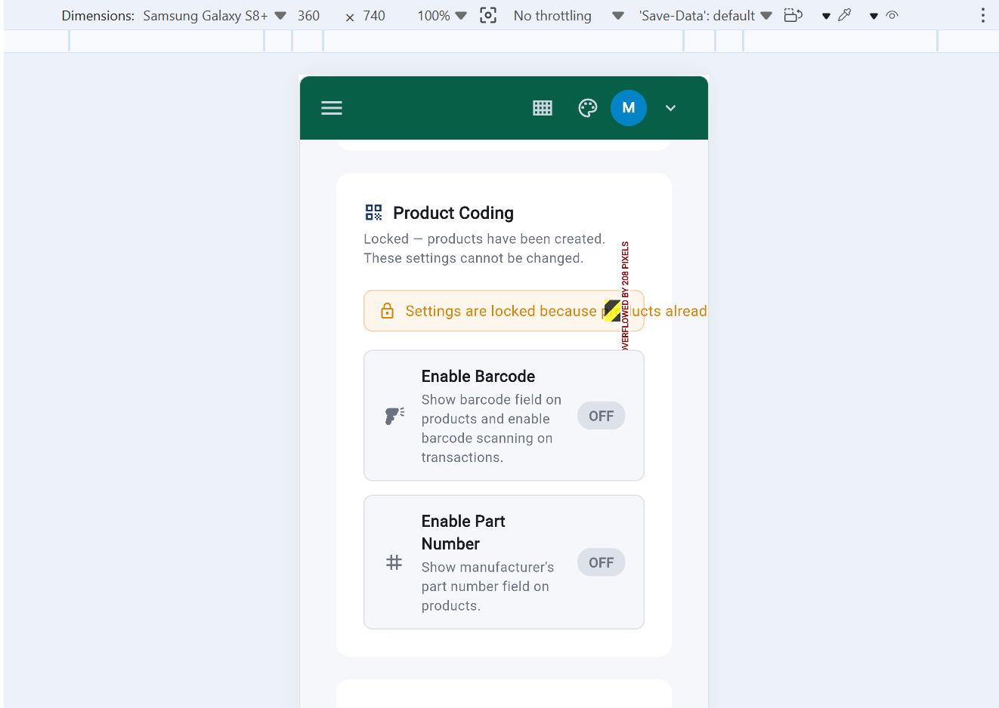
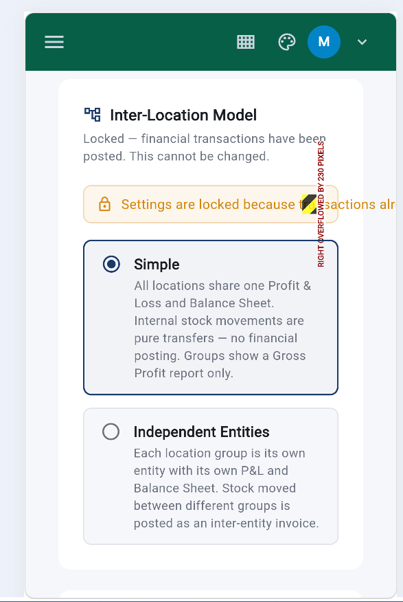

Location Setup : 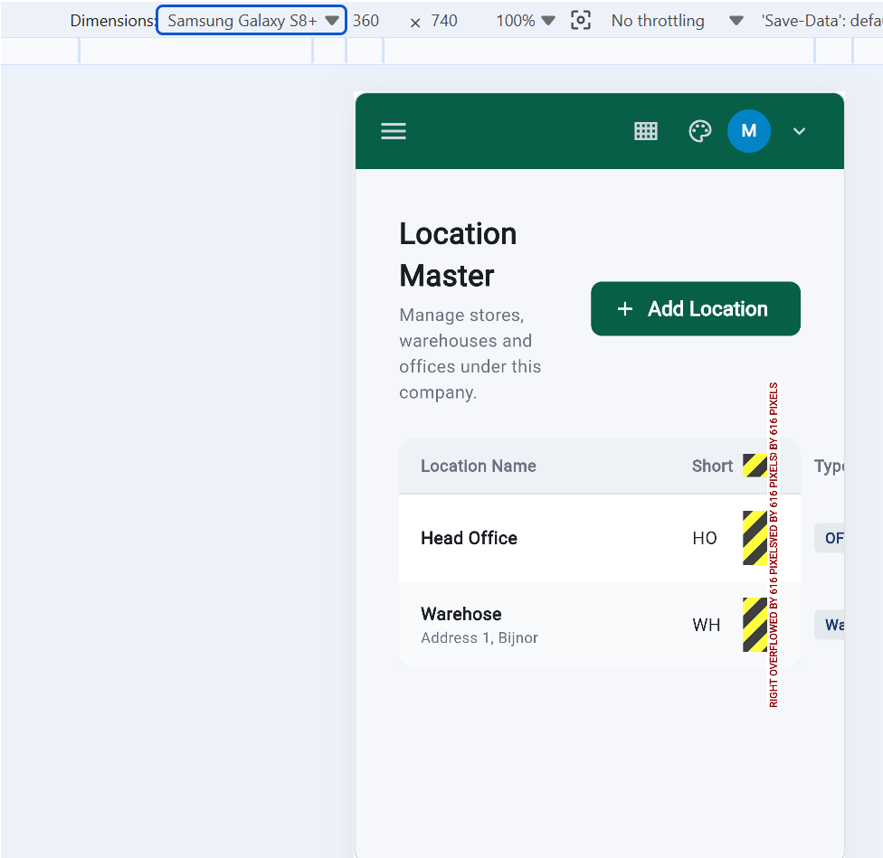

Below is currency Master screen:
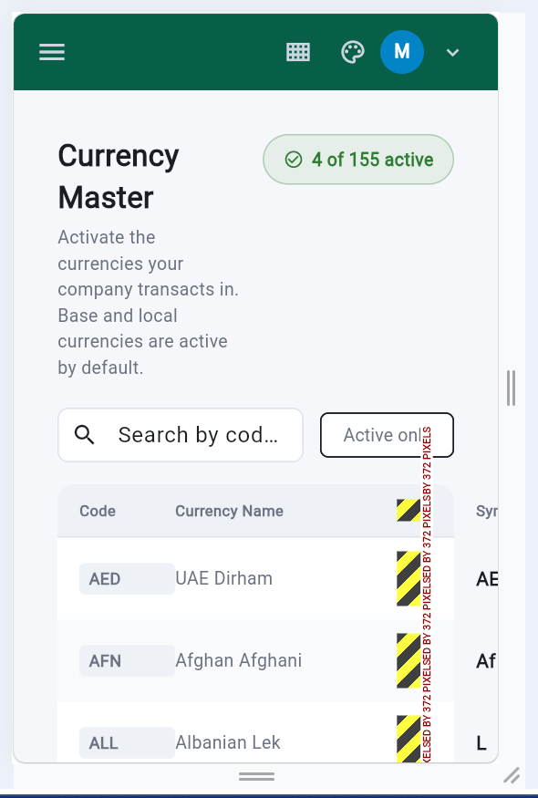

User Master List: it should be responsive on desptop and card like on mobile
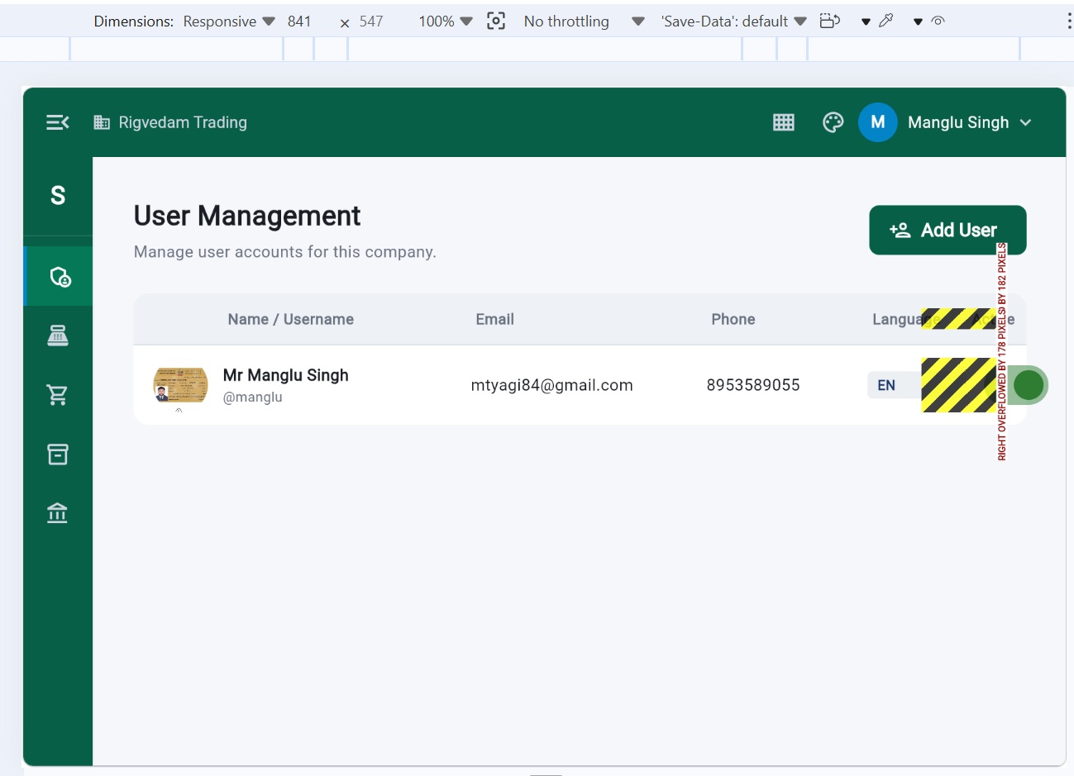
User Master creation screen
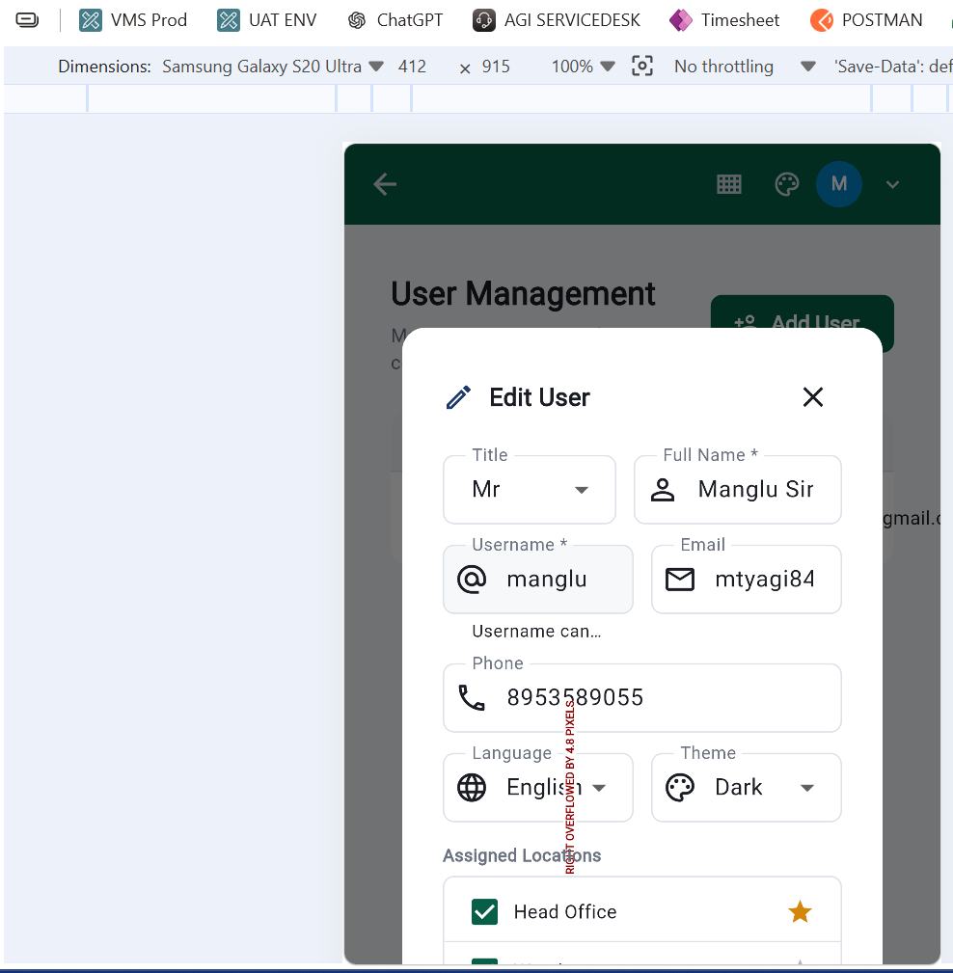

User Permission: (below)
